Review (cheatsheet)

Topics: Adverbs of frequency – Object pronouns – Must/Mustn’t – Can/Can’t – regular/irregular verbs (conjugation)

1. Object Pronouns

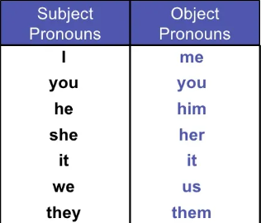

Object pronouns are used when we already know what the object we are talking is. It makes so much easier to read a sentence and avoids repetition.

1. Adverbs of frequency

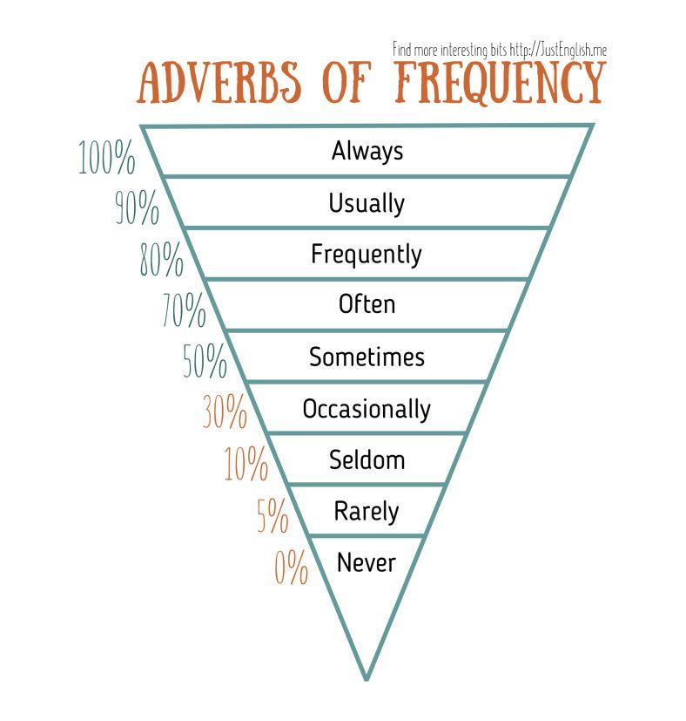

Adverbs of frequency are used to tell how often something happens in a routine or repeated activities, normally used in present simple tenses.

1. Can/Can’t

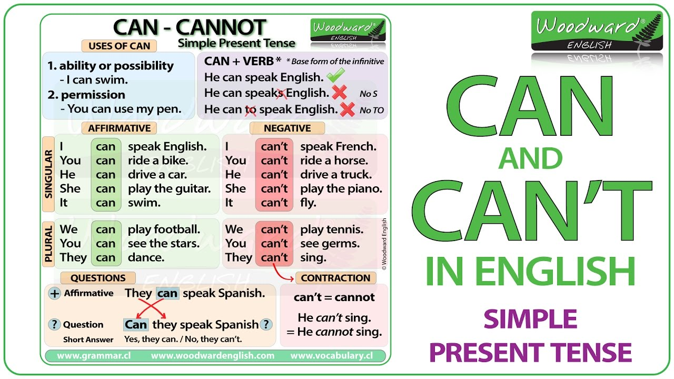  
We use can or can’t to express an ability or possibility but also it’s used to express permission to actions. There’s an affirmative, negative and question form which each one is written in different ways.

In positive and negative we write the sentence like: Person + can/can’t + verb/action + the rest of the sentence.

In a question it changes like this: can/can’t + person + verb + the rest of the sentence.

1. Must/Mustn’t

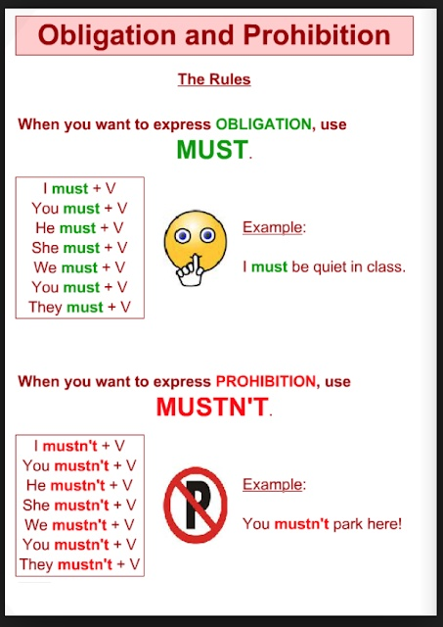

We use must to express an obligation for everyone or an specific person.  
We use mustn’t to express something that is prohibited for everyone or a person in particular.

In this case there is no question form, only positive (must) and negative (mustn’t)

1. Regular/Irregular verbs (conjugation)

